# Algorithm for file updates in Python

## Project description

The “allow_list.txt” contains allowed IP addresses. A separate remove list contains Ips to be removed. I created an algorithm to automate this task.

## Open the file that contains the allow list and read the file contents

## 

## In my function I opened the file and read the data in my ip_addresses variable.

## Convert the string into a list

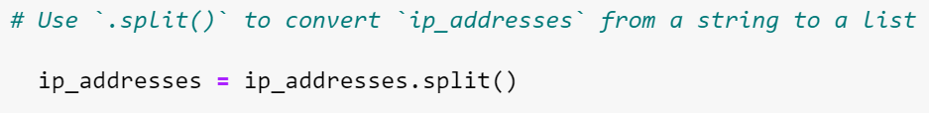

## The split function helps us convert a string into a list.

## Iterate through the remove list and remove IP addresses that are on the remove list

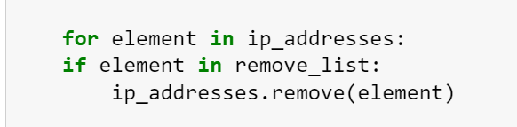

Using a for we can iterate through the list, check if the element(IP Address) is one of the ones we want to remove and remove it using remove function.

## Update the file with the revised list of IP addresses

## 

We now convert the list back to a string and write it to the same file to update it.

## Summary

I developed an algorithm to remove IP addresses listed in a remove_list variable from the "allow_list.txt" file, which contains approved IP addresses. The algorithm starts by opening the file and reading its contents as a string. This string is then converted into a list of IP addresses, stored in the variable ip_addresses. I then iterated over each IP address in the remove_list and checked if it was present in the ip_addresses list. If found, I removed it using the .remove() method. Finally, I used the .join() method to convert the ip_addresses list back into a string and wrote the updated list back into the "allow_list.txt" file.